Governance Stack Design Principles

- Authors: Drummond Reed, Victor Syntez
- Deliverable Type: Recommendation - Design Principle
- Status: PROPOSED
- Since: 2020-11-04
- Status Note: Draft
- Supersedes: N/A
- Start Date: 2020-11-04
- Tags: (see …/…/…/tags.md)
- Governance Stack Design Principles
  - Summary
  - Motivation
  - Scope
  - Important concepts
  - Trust over IP Stack Governance Frameworks description
  - Design Goals
  - List of Principles
    - 1. Interoperability and Portability
    - 2. Equity and Inclusion
    - 3. Security and Privacy
    - 4. Transparency in governance and operation
    - 5. User control and consent
    - 6. Risk and responsibilities
    - 7. Independent audit and assessment
    - 8. Human Integration for continuous feedback and consistent experience
    - 9. Minimal Disclosure for a Constrained Use
    - 10. Open and Automated systems
  - Synopsis
  - Relevance
  - Trade-offs

Summary
This document is a template for TOIP Governance Stack Design Principles that might be used throughout all or any of the Trust Over IP Layers. It is based on several works:
- Laws of Identity by Kim Cameron
- Presidio Principles by WEF
- The Principles of SSI by Sovrin (current version)
- Guiding Principles of the PCTF
- Seven Principles of Universal Design

Motivation
We see our task for creating this document in outlining TOIP Governance Stack Design Principles. We are seeking to create methodology on how to DESIGN and IMPLEMENT governance frameworks. These principles are needed for creating governing documents that will enable business, legal and social trust between entities engaged in any activity related to digitally verified credentials. By defining these principles we hope to assist in creating governance documents for user-centric, secure, accountable, interoperable, transparent and accessible utilities, protocols, applications, and ecosystems around verified credentials. Our goal lies in proposing not only the content of governance frameworks but also the way, how this content is organised for the future reading and use by humans and/or machines. We would like to highlight that these Design Principles are recommendations on HOW to create governing documents and WHAT these governing documents will contain.

Scope
This document serves to provide an opportunity to discuss how further mentioned Design Principles MUST or SHOULD, or MAY be applicable on all or any layer of TOIP Governance Stack.
In many standards track documents words MUST, SHOULD, and MAY are used to signify the requirements in the specification. This document use these words according to IETF RFC2119.

Important concepts
- Verified Credential. A Credential that includes a Proof from the Issuer. Typically this proof is in the form of a digital signature. In Sovrin Infrastructure, a Verifiable Credential uses Zero Knowledge Proofs by default and can usually be verified by the Issuer Public Key stored in the Credential Definition on the Sovrin Ledger. Based on the definition provided by the W3C Verifiable Claims Working Group. (from Sovrin glossary).
- Credential Verification is the evaluation of whether a Verifiable Credential or Verifiable Presentation authentically and accurately represents the Issuer or Presenter. This includes verification that the proof is satisfied (normally via cryptographic validation), confirmation the Credential or Presentation is valid (e.g., is not suspended, revoked, or expired), and that the Credential or Presentation conforms to relevant specifications and/or standards. (from PCTF Credential)
- Governance Framework - The set of business, legal, and technical definitions, policies, specifications, and contracts by which the members of a Trust Community agree to be governed in order to achieve their desired Levels of Assurance. Typically divided into a Master Document and a set of Controlled Documents. A Governance Framework is itself governed by a Governance Authority. A Governance Framework is also known as a Trust Framework. (from Sovrin glossary) 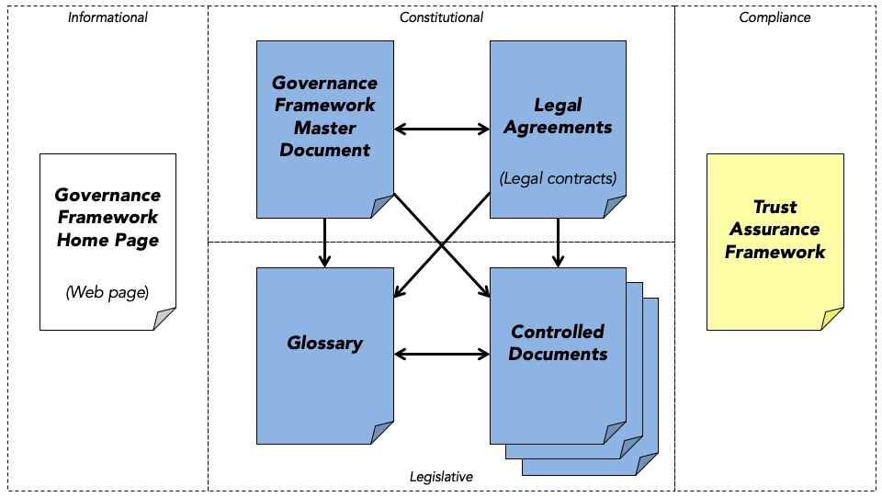

Trust over IP Stack Governance Frameworks description
The ToIP stack does not define specific governance frameworks. Rather it is a metamodel for how to design and implement digital governance frameworks that can be universally referenced, understood, and consumed in order to facilitate transitive trust online. The ToIP governance stack is designed to be compatible with—and an implementation vehicle for—national governance frameworks as well as for regional and local governance frameworks of all kinds.
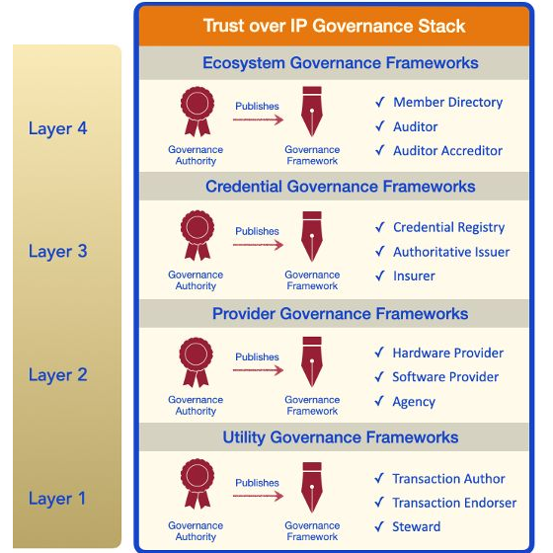
TL4: Ecosystem Governance Frameworks. Layer Four is where humans will directly experience the ToIP Governance Stack—specifically the trust marks and policy promises of ecosystem governance frameworks. These specify the purpose, principles, and policies that apply to all governance authorities and governance frameworks operating within that ecosystem—at all four levels of the ToIP stack. Any group of issuers who want to standardise, strengthen, and scale the credentials they offer can join together under the auspices of a sponsoring authority to craft a governance framework. No matter the form of the organisation —government, consortia, association, cooperative—the purpose is the same: define the business, legal, and technical rules under which the members agree to operate in order to achieve trust.
TL3: Credential Governance Frameworks. This is the layer where governance frameworks become a critical component for interoperability and scalability of digital trust ecosystems. Credential governance frameworks can be used to specify:
- Credential schema definitions.
- The rules governing who can serve as the authoritative issuers for those credentials.
- The policies those issuers must follow to issue and revoke those credentials.
- Applicable business models, liability frameworks, and insurance models.
TL2: Provider Governance Frameworks. At Layer Two, governance is needed primarily to establish interoperability testing and certification requirements, including security, privacy, data protection, for the following roles: Hardware Developer, Software Developer, Agencies.
TL1: Utility Governance Framework. A Layer One public utility may choose any governance model suited to the the constraints of its business model, legal model, and technical architecture. All ToIP architecture requires is that the governance model conform to the requirements of the ToIP Governance Stack to support both interoperability and transitive trust. This includes transparent identification of the governance authority, the governance framework, and participant nodes or operators; transparent discovery of nodes and/or service endpoints; and transparent security, privacy, data protection, and other operational policies.

Design Goals
A design is a plan or specification for the construction of an object or system or for the implementation of an activity or process, or the result of that plan or specification in the form of a prototype, product or process. For designing this document we will try to use 4 principles of universal design. Our goal is to make this document perceptible for future use outside of the Trust Over IP community. For this we seek to implement below principles:
- Equitable Use. This document is useful and marketable to people with diverse abilities and backgrounds.
- Flexibility in Use. This document accommodates a wide range of individual preferences and abilities.
- Perceptible Information. This document communicates necessary information effectively to the user.
- Size and Format for Read and Use. Appropriate size and format is provided for reading, manipulation, and use keeping in mind diversity of knowledge about verified credentials among future consumers of the document.
One of the design tasks will be to organise mentioned DP for GF in the order of their importance, in the order of their implementation and consideration. Another design task will be to use relevant verb MUST/SHOULD/MAY for every principle described.

List of Principles
Principles are mentioned without any particular order.
Interoperability and Portability | Risk and responsibilities
Equity and Inclusion | Independent audit and assessment
Security and Privacy | User-centric design
Transparency | Minimal Disclosure for a Constrained Use
User control and consent | Open and Automated systems

1. Interoperability and Portability
- MUST provide capabilities to port data between interoperable systems or parts of a system.
- MUST provide access to information sufficient to facilitate system interoperability.
- SHOULD provide access to use various verifiable data structures, wallets, or cloud service providers to manage and use verified credentials.
- SHOULD ensure users’ identification/authentication portability and interoperability, allowing for separating the data from the application and for the user to have the right to decide where to store the identification/authentication data.
- SHOULD promote different identity providers offering different features. Verified Credential ecosystem MUST be polycentric and also polymorphic.

2. Equity and Inclusion
- MUST identify and mitigate legal, procedural, and social barriers in Verified Credentials ecosystem, with special attention to groups who may be at risk of exclusion for cultural, political or other reasons.
- Verified Credentials ecosystem SHOULD NOT be used as a tool for discrimination or infringement on individual or collective rights.
- Hardware and software SHOULD be common and affordable while allowing for sufficient speed and security.
- Verified Credential ecosystem SHOULD NOT exclude or discriminate against any groups within its governance scope.
- Verified Credential ecosystem SHOULD to be easy to access and simple to understand.

3. Security and Privacy
- Data protection MUST be in accordance with internationally recognised technical security standards.
- Verified Credential ecosystem MUST have safeguards against tampering, verified credential theft, data misuse.
- MUST establish tools for end-to-end encryption.
- MUST provide verification that operations have been completed and confirmed in accordance with the system’s rules.
- Must provide security of verified credentials at rest and during exchanges.
- Protection of verified credential security and privacy through verified credential ecosystem design. Information SHOULD be protected from improper and unauthorised use by default, through both technical standards and preventative business practices.

4. Transparency in governance and operation
- MUST provide ways to assess and verify the information necessary to understand the incentives, rules, policies, and algorithms under which VC systems participants operate.
- SHOULD provide publication of the governing documents among them principles, policies, regulations, institutional mandates, etc.
- MAY provide access to the system performance metrics and critical points in service delivery system.

5. User control and consent
- SHOULD empower participants to exert their control over verified credentials by employing and/or delegating to the agents and guardians of their choice, including individuals, organisations, devices, and software.
- Verified credential ecosystem SHOULD provide capability for explicit and informed consent from its participants.
- Verified credential ecosystem MUST inform the participant whether his or her verified credential will be tracked and what data from her or his verified credential is used and released.
- The verified credential ecosystem MAY reinforce the sense that the participant is in control regardless of context. It SHOULD support user consent in enterprise as well as consumer environment.

6. Risk and responsibilities
- SHOULD ensure transparency around the roles and responsibilities of verified credential ecosystem participants.
- MUST provide clear description of potential risks and benefits of a verified credential ecosystem.
- MUST provide access to specification of the terms and conditions governing verified credential ecosystem participants relationship.

7. Independent audit and assessment
- An independent oversight body (e.g. a national privacy commission) SHOULD be created with powers to protect verified credential ecosystem participants against inappropriate access and use of their data by third parties for commercial surveillance or profiling without informed consent or legitimate purpose.
- Ecosystem-wide trust frameworks MUST be established. These frameworks will ensure on-going, functionally independent, third-party assessment of ecosystem participants.
- Verified credential ecosystem SHOULD be independently monitored for efficiency, transparency, exclusion, misuse, etc.
- Disputes regarding verified credentials and their use that are not satisfactorily resolved by the providers SHOULD be subject to rapid and low-cost review by independent administrative and judicial authorities with authority to provide suitable redress.

8. Human Integration for continuous feedback and consistent experience
- Public and private stakeholders SHOULD be engaged throughout planning and implementation of verified credential ecosystem.
- The verified credential ecosystem SHOULD extend to and integrate the human user.
- SHOULD ensure maximisation of usability and consistency of user experience.
- SHOULD provide capability to opt-out of not participation in the verified credential ecosystem that doesn’t treat data in accordance with internationally recognised governance and data protection standards.
- SHOULD encourage participants to be flexible, scalable, and meet the needs and concerns of people (users) and relying parties (e.g., public agencies and private companies).

9. Minimal Disclosure for a Constrained Use
- Verified credential ecosystem providers SHOULD disclose exactly the amount of information necessary for each interaction between only the required parties in the context of the service provided, in compliance with the applicable data protection rules.
- Verified credential ecosystem providers SHOULD not disclose any personal information unless otherwise required.
- Verified credential ecosystem providers SHOULD accept users who want to preserve high level of privacy and anonymity, e.g. by using pseudonym and/or other privacy-by-design mechanisms, associated in a trustworthy manner to their government-issued/recognised ID.
- Verified credential ecosystem providers MUST provide a possibility to revoke consent for future data collection system and support user’s “right to be forgotten”.
- Verified credential ecosystem providers SHOULD provide capabilities for users not to be subject to automated-decision making.

10. Open and Automated systems
- Maintenance of the verified credential ecosystem neutrality, openness and innovation SHOULD be ensured.
- Verified credential ecosystem SHOULD use open standards and applicable open practices.
- Verified credential ecosystem SHOULD enable open design principles for market-based competition and innovation.

Synopsis
I'm not sure if we need to add synopsis. I would like to add a message that will inspire future readers and users of this document to follow principles described in the document.

Relevance
We consider that there is a need in documents highlighting not only the very principles of verified credentials governance but also organising these principles in clear, concise, and appealing way. Therefore we wish that this document will create an emotional feedback from its consumers. We need to remember that for a product to be accepted by corresponding public it has to be of high quality and it has to be wrapped appropriately.

Trade-offs
While we will discuss how important is to seek an emotional feedback from such a document I would like us to look in two images. First one is government building in France designed by famous architect Zaha Hadid.
Second one is government building in beautiful Victoria BC.
Pictures speak a thousand words.

