COVID-19 Credentials Initiative (“CCI”)
Governance Framework V1
Credential Governance and Issuer Authority Policy v01

Document Name | Credential Governance and Issuer Authority Policy
Version | v01
Approval Date | 01 June 2020
Status | Approved
Governs | Accrediting authority, issuing authority
Governed By | CCI

This is an official document of the CCI Governance Framework V1,
as approved by the CCI Rules Workstream.
Authors: Kelly Cooper, Oskar van Deventer, Sankarshan Mukhopadhyay, Steve Mageniss, Chris Raczkowski, Alex Tweeddale, and others.

Authority Chain
COVID-19 credentials pose a unique set of constraints. The complexity involved in making and interpreting claims about medical test results is not broadly understood outside of the healthcare community. Credible experts are expected to establish policy and guidance to be administered by others along a chain of authority. As a result, formal governance is necessary to clearly communicate the roles, authority and obligations to all involved parties.
The authority chain is depicted below and consists of six distinct roles whose authority and obligations are further described in the body of this document.
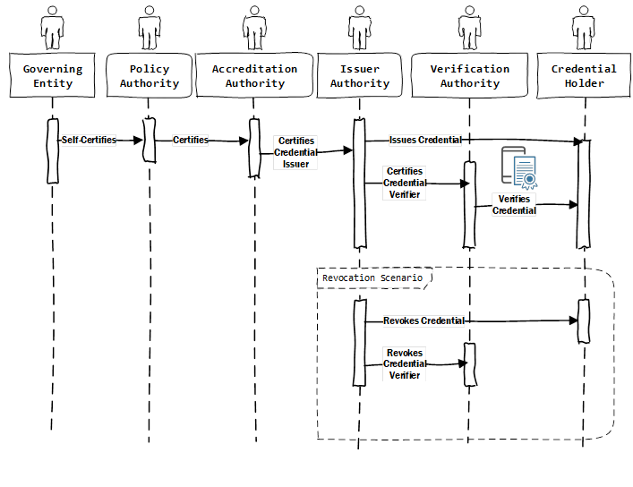

Governing Entity
The Governing Entity (GE) is the root of the authority chain. It must be a real-world entity, established by real people and thus have standing to self-certify themselves as a policy authority.

Policy Authority
The Policy Authority is responsible for formally describing information a Verifier is presented with to assist in making decisions about access, qualifications, safety, and other critical aspects related to the impact Covid-19 has on restricting the function of society. The Policy Authority may further describe formally, or informally, how a Verifier interprets the information presented to them.
Establishment of Authority
A Policy Authority (PA) self-certifies themselves as an authority and root of trust. It is essential for the sake of confidence that the population of potential verifiers recognizes the authority as reputable and trustworthy. Multiple Policy Authorities may exist; however, extra care is needed between authorities to avoid policies that conflict.
Establishment of Policy
A PA formal process defines a policy or set of policies that establish the conditions upon which a C19 credential is used, for example, to permit a person to board a train. The policy may be suggested best practices or extend to have the power of law enforcement behind it. As part of setting policy, the PA formally defines the characteristics and data elements of the credential(s) that a Verifier checks and evaluates as a means of complying with and enforcing the policy.
Change of Policy
The PA formal process for managing policy change, at minimum, includes:
- A means of updating policy and credential definitions
- A means of formally documenting changes
- A means of communicating such change to Accreditation Authorities, credential Issuers and the public at large
- As necessary, the PA formal process to monitor and enforce adoption of changes
Establishment of Accreditation Authority Terms
The PA, as a self-appointed and trusted agent, formally establishes and maintains a policy that allows authorization of another party (or themselves) to be an Accreditation Authority (AA) for C19 credentials.
The PA formally establishes and maintains terms where an AA is required to represent the goals of the PA.
A legally binding agreement executes between each PA and AA. The PA is responsible for maintaining records.
Issuance of Authority Credential
The PA issues a Verifiable Credential to each AA they certify. The Verifiable Credential attests that the PA acts as a root of trust and is an authorized AA in good standing.
Revocation of Authority Credential
The PA revokes the credential of any AA certified by them if the AA does not operate under the agreed-to terms.
Appeal of Revocation
The PA formal policy allows an AA to appeal the revocation of their authority credential. The PA determines if the AA is permitted to continue operating as an AA for C-19 credentials during the appeal process.
Oversight Responsibility
It is the responsibility of the PA to ensure each AA operates in good faith within the terms of their agreement. If not, the PA should take appropriate action to mitigate and correct the problem and, if necessary, revoke the authority credential issued to the AA.

Accreditation Authority
It is the responsibility of the AA to certify Issuers and as required Verifiers, and ensure they operate in compliance issuing and verifying credentials defined by the PA’s C19 policy.
Establishment of Authority
A PA certifies an AA. The terms of the authority are memorialized in a written agreement between the PA and the AA, which may or may not be legally binding. It is crucial for the sake of confidence that the AA be reputable, trustworthy, and operate following the agreement. Several AAs may exist to serve the needs of the market adequately. A PA may reserve AA certification authority exclusively for themselves.
Establishment of Issuer Terms
The AA formally establishes and maintains a policy under the terms of their accreditation agreement with the PA that allows them to authorize another party, specifically not themselves nor an authorized Verifier, to be an Issuer of C-19 credentials.
The AA, as a trusted agency certified by a PA, formally establishes and maintains the terms under which an Issuer is required to operate C-19 credentials.
A written issuer agreement, which may or may not be legally binding, should be executed between each AA and Issuer. The AA is responsible for maintaining records of issuer agreements.
Establishment of Verifier Terms
The AA formally establishes and maintains a policy under the terms of their accreditation agreement with the PA that allows them to authorize another party, specifically not themselves nor an authorized Issuer, to be a Verifier of C-19 credentials.
The AA, as a trusted agency certified by a PA, formally establishes and maintains the terms under which a Verifier is required to operate C-19 credentials.
A legally binding agreement executes between each AA and Verifier. The AA is responsible for maintaining such records.
Issuance of Authority Credential
The AA issues a Verifiable Credential to each Issuer or Verifier they certify. The Verifiable Credential attests the Issuer or Verifier is authorized by the AA to issue or verify C-19 credentials, AND the AA, in turn, is authorized by the PA to certify the Issuer.
Revocation of Authority Credential
The AA revokes the credential of any Issuer or Verifier certified by them if the Issuer or Verifier does not operate under the agreed-to terms.
If the authority credential of the Accreditation Authority is itself revoked by the PA and cannot be reinstated, all Issuers or Verifiers certified by the AA must recertify with a different AA to continue operation. It is assumed that all actions by Issuers and Verifiers before revocation remain valid unless specific circumstances dictate otherwise.
Appeal of Revocation
The AA has a formal policy that allows an Issuer and Verifiers to appeal the revocation of their authority credential. The AA determines if the Issuer is permitted to continue operating as an Issuer or Verifier of C19 credentials during the appeal process.
Oversight Responsibility
It is the responsibility of the AA to ensure each Issuer and Verifier operates in good faith within the terms of their agreement. If not, the AA is required to take appropriate action to mitigate and correct the problem and, if necessary or unresolvable, revoke the authority credential issued by them.

Issuer Authority
It is the responsibility of the Issuer to issue C-19 Verifiable Credentials compliant with those as specified by the PA to credential Holders. The Issuer is responsible for collecting, calculating, or otherwise processing the information contained in the C-19 credential(s) and for the accuracy and correctness of such information.

Establishment of Authority
An AA certifies an Issuer Authority (IA). The terms of the authority are memorialized in a legally binding agreement between the AA and the Issuer. It is critical the Issuer be reputable, trustworthy, and operate under the agreement. Many Issuers will exist to serve the needs of the market adequately, and Issuers may be authorized to issue credentials from other chains of authority.
Authorization of Proxy Issuer
If permitted by the agreement with the AA, an Issuer may elect to engage the services of a proxy issuer so long as the Issuer ensures their proxy conforms to the required responsibilities and conditions.
Issuance of a C-19 Credential
The Issuer (or proxy Issuer) may issue to a Holder, a Verifiable Credential that conforms to the terms of their agreement with the AA. The Verifiable Credential attests to the fact(s) defined by the PA and agreed to by the Issuer and AA. The credential contains, at minimum, proof for the Validator that the Issuer is authorized by an AA who, in turn, is authorized by the PA, and that all parties in the authorization chain are in good standing.
Revocation of C-19 Credential
It is not anticipated that an Issuer or proxy Issuer revokes C-19 credentials once issued. An Issuer may issue a formal revocation policy if deemed necessary.
Appeal of Revocation
It is not anticipated that an Issuer or proxy Issuer will have an appeal process. An Issuer may issue a formal appeal policy if deemed necessary.
Oversight Responsibility
It is not anticipated that an Issuer or proxy Issuer will have oversight responsibility for the Holder. An Issuer may issue a formal oversight policy if deemed necessary.

Verification Authority
When it is desirable for a Verifier to be authorized to ensure compliance with the full authority chain, the Verifier is responsible for verifying Credentials in accordance with the Policy and under the authority of the Accreditation Authority. It is permissible for a Verifier to operate without explicit authorization of authority if permitted by Policy.
Establishment of Authority
As applicable, an AA certifies a Verification Authority (VA). The terms of the authority are memorialized in a legally binding agreement between the AA and the Verifier. It is critical the Verifier be reputable, trustworthy, and operate under the agreement. Many Verifiers will exist to serve the needs of the market adequately, and Verifiers may be authorized to verify credentials from other chains of authority.
Authorization of Proxy Verifier
If permitted by the agreement with the AA, a Verifier may elect to engage the services of a proxy verifier so long as the Verifier ensures their proxy conforms to the required responsibilities and conditions.
Verification of a C-19 Credential
The Verifier is charged with evaluating the contents of a presented Credential in accordance with applicable Policy or Policies and for taking action in accordance with such policies.
The Verifier at a minimum is responsible for confirming the authenticity and reputation of the Issuer and for confirming to the extent possible, the authenticity of the holder and their relationship to the subject of the credential.
Oversight Responsibility
It is not anticipated that a Verifier or proxy verifier will have oversight responsibility beyond any immediate decision made or action taken based on their evaluation of a presented credential . A Verifier may issue a formal oversight policy if deemed necessary.

Credential Holder
For completeness, the role of a Credential Holder is included as a participant in the authority chain. The Holder exists between Issuer and Verifier and is typically the subject of the credentials they hold. The Holder operates as an independent entity and as such may not be subject to any authority or obligations described in this document.

